|  |  |  |  |
| --- | --- | --- | --- |
| **Instructor** |  | **Due Date** |  |

**PROJECT OOP in Java - Data Encryption and The Caesar Cipher 50 points**

**Objective** To use the Caesar cipher to encrypt login passwords.

***PROJECT DESCRIPTION***

Using the Caesar cipher, you will encrypt a set of passwords.

***Information about this Project***

A type of substitution cipher is the Caesar cipher. This cipher is mono - alphabetic since only one alphabet was used. In a substitution cipher, every letter of the plain text is substituted by the some other letter or symbol. The substitution in the Caesar cipher is based on a shift operation performed on the letters of the plaintext. For example if the shift 4 , then the standard alphabet

|  |  |  |  |  |  |  |  |  |  |  |  |  |  |  |  |  |  |  |  |  |  |  |  |  |  |  |
| --- | --- | --- | --- | --- | --- | --- | --- | --- | --- | --- | --- | --- | --- | --- | --- | --- | --- | --- | --- | --- | --- | --- | --- | --- | --- | --- |
| A | B | C | D | E | F | G | H | I | J | K | L | M | N | O | P | Q | R | S | T | U | V | W | X | Y | Z |  |

becomes

|  |  |  |  |  |  |  |  |  |  |  |  |  |  |  |  |  |  |  |  |  |  |  |  |  |  |  |
| --- | --- | --- | --- | --- | --- | --- | --- | --- | --- | --- | --- | --- | --- | --- | --- | --- | --- | --- | --- | --- | --- | --- | --- | --- | --- | --- |
| E | F | G | H | I | J | K | L | M | N | O | P | Q | R | S | T | U | V | W | X | Y | Z | A | B | C | D |  |

and a plaintext message such as " PURCHASE NOW " is encrypted as " TYVGLEWI RSA " .

Notice that the letter P was shifted as T , the letter U as Y , and so on.

***Steps to Complete this Project***

**STEP 1** **Open Eclipse, JCreator or Similar Java IDE**

Open Eclipse, JCreator or similar Java editor on your computer and create a new Java Project called Caesar. Next add a class to your project called Encryptor. Within your new class file, type the Java code from in **Figure 1** below.

**STEP 2** **Test the File1**

Run your program. Your program should display an input box similar to the

screen snapshot segment given below.

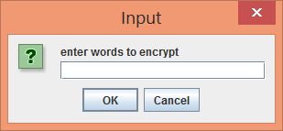

Into the text field, enter a password to encrypt, such as the word **subterfuge** and then in the next field **key**, enter a Caesar key shift such as the number **6** .

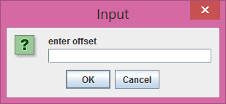

Observe the output that results.

**PROJECT OOP in Java - Data Encryption and The Caesar Cipher**

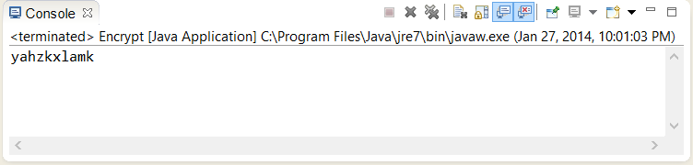

**STEP 3** **Dissect the Initial Program Code**

Examine in detail the code given in **Figure 1** . The bulk of the program code lies within the **Encryptor()** constructor that has a **String** return type.

**STEP 4** **Modify the File**

Return to your Java IDE and modify the file such that the user can enter a cipher text ( encrypted ) message and a key and your program will decrypt the message.

One way to modify the program is to first declare a class level variable.

**public String cipherText;**

Then supplement the **main()** method with the instantiation of a new object that will be used to perform the decryption.

Notice that in the main method the cipher text, i.e. the decrypted text, is assigned to a global variable in order for it to be used in the **Decrypt()** method.

|  |
| --- |
|  |

|  |
| --- |
| **public static void main(String [] args) {**    **// encryption block**  **Encryptor d = new Encryptor();**  **String strCipherText = d.Encrypt();**  **System.out.println(strCipherText);**    **// decrypt block**  **Encryptor d = new Encryptor();**  **// cipher text becomes the input text to the Decrypt method**  **d.cipherText = strCipherText;**  **String strPlainText = d.Decrypt();**  **System.out.println(strPlainText);**    **System.exit(0);**  **}** |

|  |
| --- |
|  |

**PROJECT OOP in Java - Data Encryption and The Caesar Cipher**

Within the class definition add a **Decrypt()** method. Copy the code from the **Encrypt()** method and place it into the **Decrypt()** method.

Now alter the copied code in the **Decrypt()** method such that the following occur.

|  |
| --- |
| **plainText = ((String)JOptionPane.*showInputDialog*("enter words " +**  **"to decrypt")).toLowerCase().trim();** |

Change the above line of code to:

**plainText = cipherText;**

Finally change this copied block of code in the **Decrypt()** method such that instead of performing a forward shift you will now perform a backward shift.

**offset += shift;**

**if(offset > 25)**

**{**

**newOffset = offset % 26;**

**sb.append(alphabet.charAt(newOffset));**

**}**

**else**

**{**

**sb.append(alphabet.charAt(offset) );**

**}**

A sample trial run of your modified program could appear as follows.

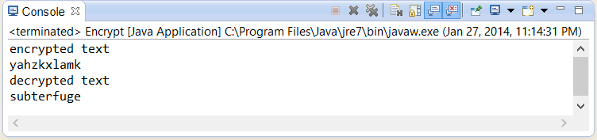

**STEP 5** **Submit the File**

Submit your original and modified source code file for credit. Include screen snapshots showing the operation of your program with the above snapshotted encrypted and decrypted text results.

**PROJECT OOP in Java - Data Encryption and the Caesar Cipher**

**Figure 1 Caesar Cipher Program Code**

|  |
| --- |
|  |

|  |
| --- |
| **import javax.swing.*;**  **public class Encryptor {**  **private String plainText;**  **private int shift;**    **public Encryptor() {**  **plainText = null;**  **shift = 0;**  **}**  **public static void main(String [] args) {**  **Encryptor e = new Encryptor();**  **String strCipherText = e.Encrypt();**  **System.out.println(strCipherText);**  **System.exit(0);**  **}**  **public String Encrypt()**  **{**  **plainText =**  **((String)JOptionPane.showInputDialog("enter words " +**  **"to encrypt")).toLowerCase().trim();**  **shift =**  **Integer.parseInt(JOptionPane.showInputDialog("enter offset"));**  **int offset = 0;**  **int newOffset = 0;**  **String alphabet = "abcdefghijklmnopqrstuvwxyz";**  **StringBuffer sb = new StringBuffer();**  **int index = plainText.length();**  **for(int i = 0; i < index; i++)**  **{**  **String temp = "" + plainText.charAt(i);**  **offset = alphabet.indexOf(temp);**  **offset += shift;**  **if(offset > 25)**  **{**  **newOffset = offset % 26;**  **sb.append(alphabet.charAt(newOffset));**  **}**  **else**  **{**  **sb.append(alphabet.charAt(offset));**  **}**  **}**  **return sb.toString();**  **}**  **}** |

|  |
| --- |
|  |